Low fidelity prototyping is a method of creating rough and simple versions of a design in the early stages of UX design. It involves using basic tools and materials such as paper, markers, and sticky notes to create sketches and mockups of the design.

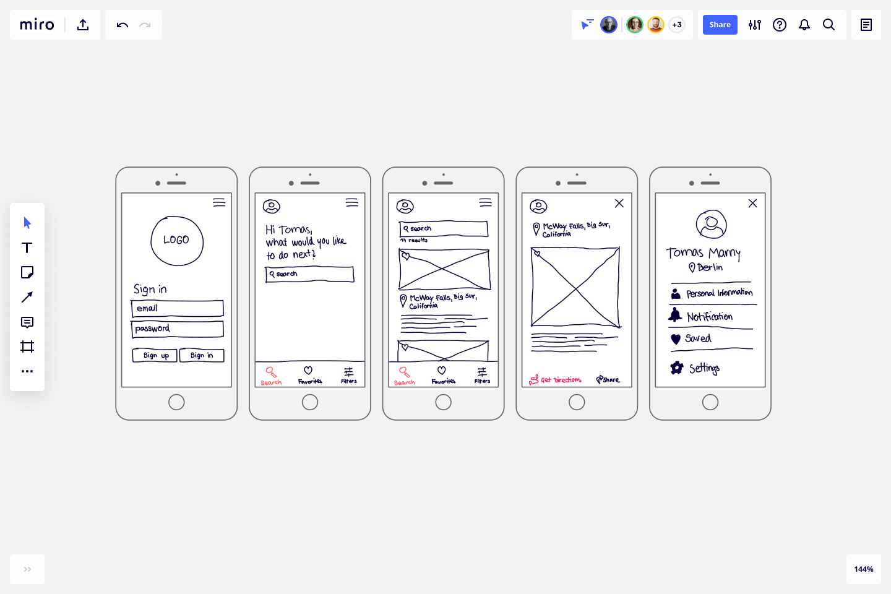

AN PHONE VS MAP UP IN FIGMA

The purpose of low fidelity prototyping is to quickly explore and test different design ideas without investing too much time or resources. It allows designers to get feedback from users and stakeholders early on in the design process, and to iterate and refine the design based on that feedback.

Low fidelity prototypes are typically low-tech and quick to produce, which makes them ideal for exploring different design options and getting early feedback. They are also easy to modify and update as the design evolves.

Some tips for creating effective low fidelity prototypes include keeping it simple, focusing on the key aspects of the design, and testing early and often. It's important to remember that low fidelity prototypes are not meant to be perfect, but rather to help designers explore and refine their ideas in a quick and iterative way

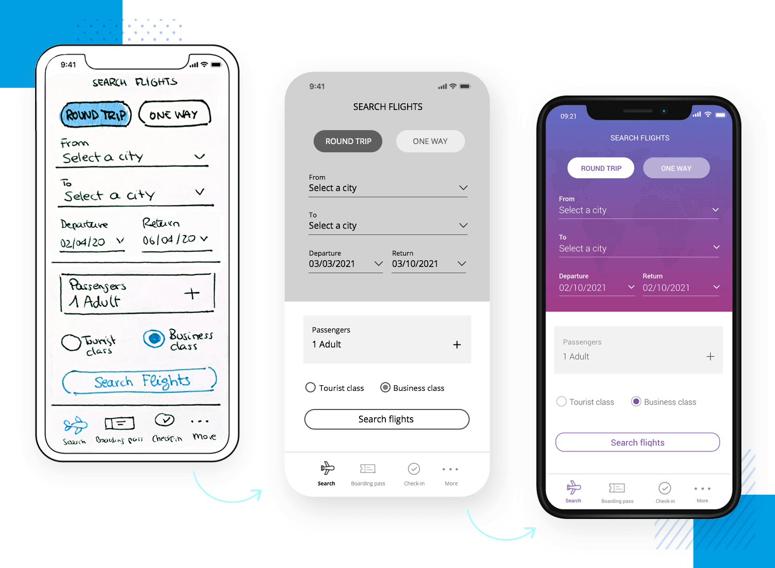

Various stages of an design